Dear Parents of Seniors,
Is your student graduating this year? Pre-order a Graduate Lawn Sign and save 15%!
The PTSO needs your help so we can support school events and activities such as the Senior Yearbook Signing Party, Back to School Night Refreshments, Homecoming Dance and Student Dinner, Senior Scholarships and Teacher Appreciation.
One of the easiest ways to support the PTSO is to pre-order a “Congratulations Graduate!” Lawn Sign to celebrate your student’s graduation! Act now to pre-order your sign for just $25.00! Later this year, Lawn Signs will be sold for $30 each but order by 10/01/18 and you can purchase a Graduate Lawn Sign and save 15%.
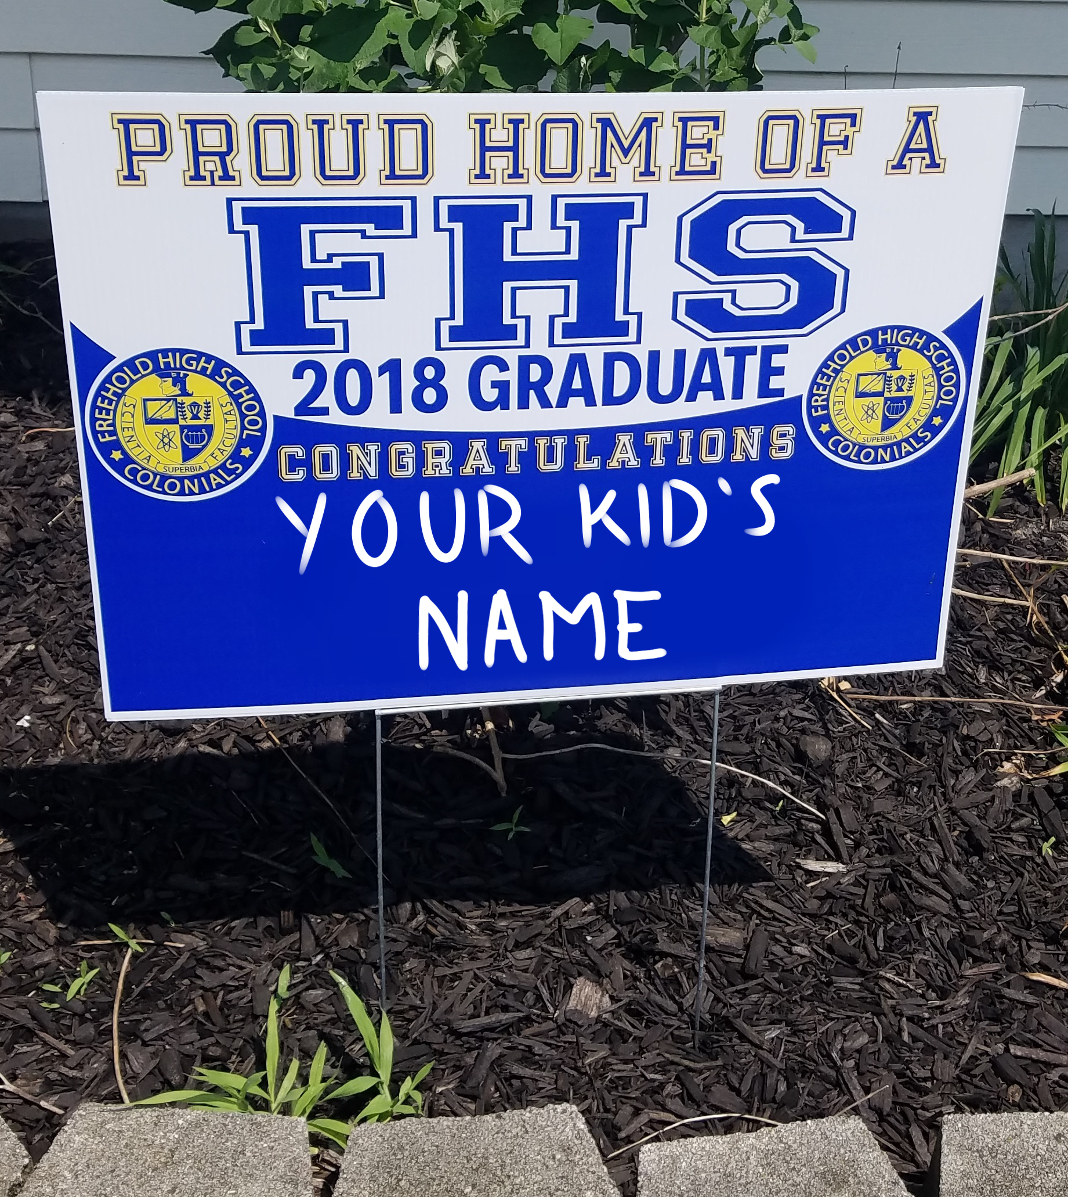
All orders are due by 05/01/2019. You will be contacted when to pick up the sign (around 06/01/2019). Place a $25 check (payable to the “FHS PTSO”) & this form in a sealed envelope to the school office. Write your child’s full name and “Grad Sign” on the outside. Please email all questions to rebecca.greenman@gmail.com -------------------------------------------------------(cut here)---------------------------------------------------
Name of graduate: ________________________________________________________
(as you would like it to appear on the sign)
Parent’s name: ____________________________________________________________
Your phone number: ( _ _ _ ) _ _ _ - _ _ _ _
Amount enclosed: $ __________________ Check number: ____________________
Thank you for supporting the Freehold High School PTSO!

